**Assignment No.6**

Q) Pizza parlour accepting maximum n orders. Orders are served in FCFS basis. Order once placed can’t be cancelled. Write java program to simulate the system using circular Queue.

INPUT:-

**package** fds_tut3;

**import** java.util.*;

**public** **class** assignment_6 {

**public** **int** front=-1,rear=-1,count=0;

**public** **int** N=5;

**public** **int** orders[]=**new** **int** [N];

assignment_6()

{

front=rear-1;

}

Boolean Enque(**int** id) {

**if**(rear==-1)

{

front=rear=0;

orders[rear]=id;

**return** **true**;

}

**else**

{

**int** pos=(rear+1)%N;

**if**(pos==front)

{

System.***out***.println("\nCafe is Full.Please wait.\n");

**return** **false**;

}

**else**

{

rear=pos;

orders[rear]=id;

**return** **true**;

}

}

}

**void** Deque()

{

**if**(front==-1)

{

System.***out***.println("\n No Orders in Cafe.[Cafe is Empty)\n");

**return**;

}

**else**

{

System.***out***.println("\n Order No. "+orders[front]+" is processed.\n");

**if**(front==rear) //only one order

{

front=rear=-1;

}

**else**

{

front=(front+1)%N;

}

}

}

**void** display()

{

**int** i=0;

**if**(front==-1)

{

System.***out***.println("\nCafe is Empty.No orders.\n");

**return**;

}

**else**

{

System.***out***.println("Order Id's: \n");

**for**(i=front; i!=rear; i=((i+1)%N))

{

System.***out***.println(orders[i]+" ");

}

System.***out***.println(orders[rear]);

}

}

**public** **static** **void** main(String[] args) {

// **TODO** Auto-generated method stub

**int** ch,id=0;

Scanner sc= **new** Scanner(System.***in***);

assignment_7 q=**new** assignment_7();

**do**

{ System.***out***.println("\n\n\n------------------------\nWELCOME TO EAT AND REPEAT\n------------------------\n");

System.***out***.println("\n***Menu**\n1. Accept order\n2. Serve order\n3. Display orders\n4. Exit");

System.***out***.println("\nChoice: ");

ch=sc.nextInt();

**switch**(ch)

{

**case** 1:

id++;

**if**(q.Enque(id))

{

System.***out***.println("Thank you for order.\nOrder id is : "+id);

//id=sc.nextInt();

}

**else**

{

id--;

}

**break**;

**case** 2:{ q.Deque();

**break**;}

**case** 3: {q.display();

**break**;}

}

}**while**(ch!=4);

System.***out***.println("\nThank You.Keep Visiting.");

}

}

OUTPUT:-

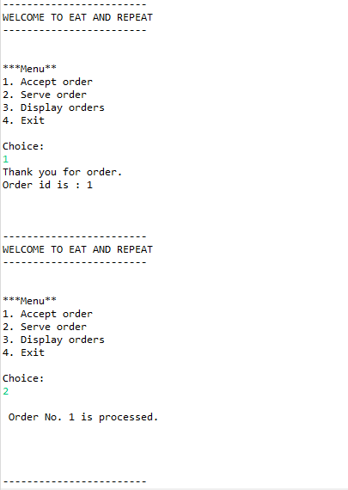

Name:- Yashraj Vijay Aware

PRN no:- 22110167

Roll No.:-224006

Div:-D

Div.:-D1